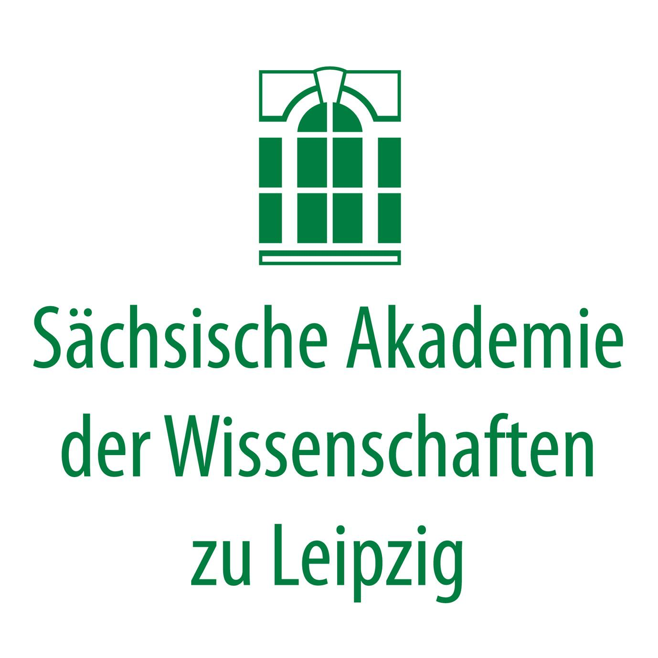
SAW
Sächsische Akademie der Wissenschaften,
“Buddhist Murals of Kucha on the Northern Silk Road”

UNIVERSITÄT LEIPZIG
Institut für Indologie und Zentralasienwissenschaften

SEECHAC
Societé Européenne pour l’Étude des Civilisations de l’Himalaya et de l’Asie Centrale
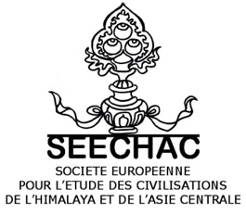

Kucha and Beyond: Divine and Human Landscapes from Central Asia to the Himalayas
Bibliotheca Albertina,
Vortragssaal,
Beethovenstraße 6
04107 Leipzig
2–4 November 2021

TUESDAY, 2 NOVEMBER

8:30 Registration

9:00–9:30 Welcome and Introduction
Hans WIESMETH, President, SAW
Eli FRANCO, Project Leader, “Buddhist Murals of Kucha on the Northern Silk Road”, SAW
Monika ZIN, Research Team Leader, “Buddhist Murals of Kucha on the Northern Silk Road”, SAW,
Charles RAMBLE, President, SEECHAC

9:30–10:00 Special Presentation: Why Kucha?
Monika ZIN

10:00–10:30 Tea/Coffee

Morning Chair: Stefan Baums

10:30–11:00 Monika ZIN
Mountains inside the Living Stone – The Magical Hillscapes of Kucha Cave Vaults

11:00–11:30 Robert ARLT
A Unique Depiction of Lake Anavatapta in Kizil Cave 206

11:30–12:00 Tea/Coffee

12:00–12:30 Ji Ho YI
Sacred Mountains Where Enlightened Beings Reside: Rows of Buddhas and Pratyekabuddhas in Kucha and Dunhuang

12:30–13:00 Fang WANG
The “Stole-Dance” Figure as Part of Heavenly Landscapes and Representation of Secular Life along the Silk Road

13:00–14:30 Lunch

Afternoon Chair: Marta Sernesi

14:30–15:00 Osmund BOPEARACHCHI
The Buddha Performing the ‘Twin Miracle’ Creating the Spatial Cosmos

15:00–15:30 Robert SCHULZ
The We and the Other: Representations of Cultural Landscapes in the Iconography of Central Asia at the Transition between Late Antiquity and the Early Middle Ages

15:30–16:00 Tea/Coffee

16:00–16:30 Zhan ZHANG
The Scribal Landscape across the Tarim Basin: A Comparative Study of Secular Documents in Tocharian and Khotanese

16:30–17:00 Stefan BAUMS
Three New Documents from Ancient Niya

18:00 Reception

WEDNESDAY, 3 NOVEMBER

8:30 Registration

Morning Chair: Osmund Bopearachchi

9:00–9:30 Mariachiara GASPARINI
Tailoring Tocharian Clothing: A Structural and Textile Analysis

9:30–10:00 Astrid KLEIN
The Imitation of a Cloud-and-Animal Silk Painted on a Reliquary Box from Kucha

10:00–10:30 Fiona KIDD
Human Landscapes in Khorezm: Akchakhan-kala and the Interplay of Contiguous Ecological Zones

10:30–11:00 Tea/Coffee

11:00–11:30 Elisa IORI
Overlapping Landscapes at the City of the Vajra (Barikot, Swat)

11:30–12:00 Anusha VIKRAM
The Substratum of Nicholas Roerich’s Landscape Paintings of Central Asia and the Trans-Himalayas

12:00–12:30 Olaf CZAJA
Presenting Tibet’s India to the British King

12:30–14:00 Lunch

Afternoon Chair: Amy Heller

14:00–14:30 Cecilia DAL ZOVO
Paths to the Sky: Pastoral and Ritual Mobility in a Sacred Mountain Landscape of Mongolia

14:30–15:00 Agata BAREJA-STARZYŃSKA
Buddhist Hellish Landscapes in the Mongolian Tradition -- Texts and Images Revisited", Part 1/2

15:00–15:30 Magdalena SZPINDLER
Hellish Landscapes in Molon Toyin’s Story: Familiar, Fearsome and Magical, Part 2/2

15:30–16:00 Tea/Coffee

16:00–16:30 Gerald KOZICZ
The Landscape Mandala of the Assembly of the 100 Peaceful and Wrathful Deities

16:30–17:00 Marta SERNESI
Tsib-ri Hermits and Hermitages: Historical Religious Landscape in South-Western Tibet

THURSDAY, 4 NOVEMBER

9:00 Registration

Morning Chair: Agata Bareja-Starzyńska

9:30–10:00 Diane ZHANG-GOLDBERG
Weaving Heterogeneous Landscapes: Tangut Depiction of Deities within Terrestrial Landscapes and Integration of Sacred Landscapes in Funerary Architecture

10:00–10:30 David C. ANDOLFATTO
The Archaeology of the Fire Temples of Dullu, West Nepal

10:30–11:00 Amy HELLER
Human Landscapes from Early Tibet

11:00–11:30 Tea/Coffee

11:30–12:00 Diana LANGE
The Diverse Mapping of Tibetan Human Landscapes

12:00–12:30 Brigitte STEINMANN
The Multiple Dimensions of the Construction of a ‘Hidden Landscape’ on the Borders of the Three Ancient Himalayan Kingdoms (Tibet, Sikkim, Nepal)

12:30–14:00 Lunch

Afternoon Chair: Brigitte Steinmann

14:00–14:30 Haiyan HU-VON HINÜBER
Two Newly Found Bronze Statues with Sanskrit Inscription Originating from Historical Northwest India

14:30–15:00 Petra MAURER
Ways of looking at the landscape in the Tibetan Geomancy (sa dpyad)

15:00–15:30 Tea/Coffee

15:30–16:00 Charles RAMBLE
The Many Mansions of a Tantric Divinity of the Tibetan Bon Religion

16:00–16:30 Antje LINKENBACH
Travelling Deities: The Spatial-Political Dimension of Religion in Uttarakhand (India)

19:00 Festive Dinner

FRIDAY, 5 NOVEMBER
Optional excursion to the collection of the Museum of Asian Art at the Humboldt Forum, Berlin, and guided tour by the curator of the Central Asian art collection Dr. Lilla Russell-Smith.

The conference venue Bibliotheca Albertina can be reached on foot or by public transport from Leipzig Hauptbahnhof OR Motel One (Nikolaikirche):
- Bus no. 89 (Connewitzer Kreuz) from Hauptbahnhof OR Reichsstraße to Mozartstraße, every 10 min.
- Tram no. 11 (Markkleeberg) from Hauptbahnhof OR Augustusplatz to Münzgasse/LVZ, every 6 min.
- Tram nos. 15 (Meusdorf), 16 (Lößnig), 31 (S-Bahnhof Connewitz) from Hauptbahnhof OR Augustusplatz to Härtelstraße, every 3 min.

This conference is made possible by the financial support of the DFG (German Research Foundation), the Academy Programme, a research funding programme co-financed by the federal and state governments, and the Saxon state government from the state budget approved by the Saxon state parliament.

Cover: Detail of a painting from the right side wall of the main chamber of Kizil Cave 207 (Malerhöhle), Kucha (Xinjiang, PR China), early 6th c. ©Staatliche Museen zu Berlin, Museum für Asiatische Kunst / J. Liepe.

